AIM: To learn:

* + to display text in the GAME screen using a GUILayout.Label() statement

**Preparation/Setup**

* Create a new, empty Unity project
* Create folder “Scenes”, to store your scenes
  + Save into this folder the current (empty) scene as “scene1”
* Create folder “Scripts”
  + You’ll be storing your program files in here !

**Notes**

* Your project should look as follows after setup:

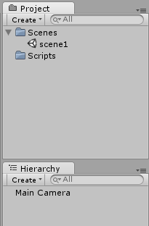

# Create a new CSharp program file “HelloLabel”

Do the following:

* In your Scripts folder, create a new Csharp file “HelloLabel”

# Edit your Class

Do the following:

* Open your class in the script editor
* Remove the empty Start() and Update() methods
* Write an OnGUI() method as follows:

using UnityEngine;

using System.Collections;

public class HelloLabel : MonoBehaviour {

private void OnGUI(){

GUILayout.Label(“hello world”);

}

}

* Save your work and return to the Unity editor

# Attach an instance of your class to the Main Camera

Do the following:

* In the Unity editor, select the Main Camera, and then draft your script HelloLabel into the Inspector, to add an instance of your class as a component of the MainCamera

# Run your program

